BILLING TO SPEEDTYPE
Select Speed Type for the form of payment and continue making your reservation.

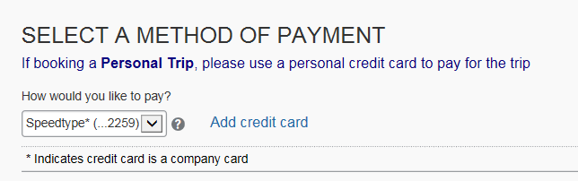

The 4-digits above are not Speed Type numbers. If you are not adding a credit card, please click “Reserve Flight and Continue” below.

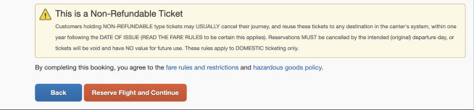

When you get to the TRIP BOOKING INFORMATION page, you will add your Speed Type number -
Click on the blue button

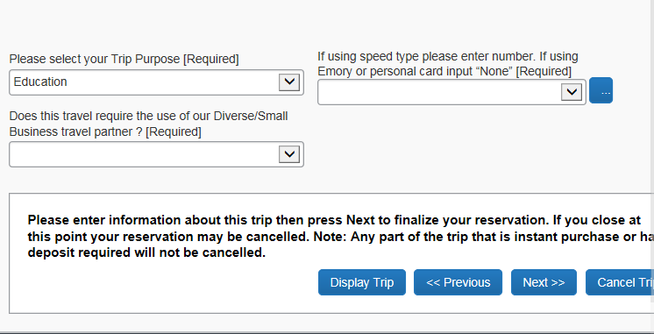
Start typing the speed type number in the highlighted box (or None if you are using an alternate credit card)

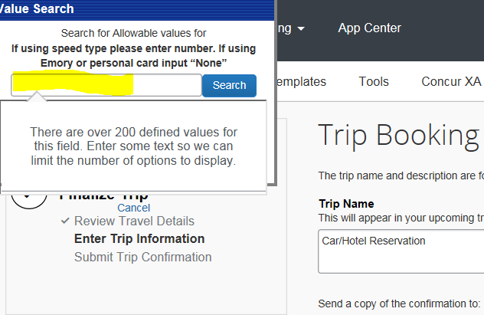

Select the correct code (or None)

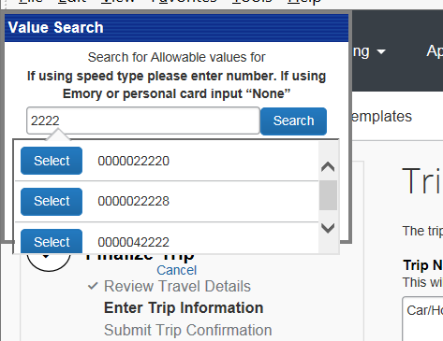

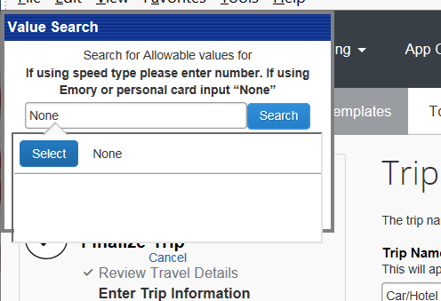

Then continue until you finish the reservation.

