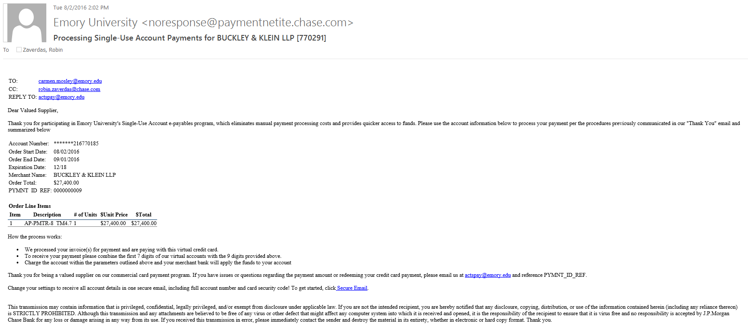
SUA – Process your Payment Email Example

